Community School Proudly Presents…
The Sixth Annual
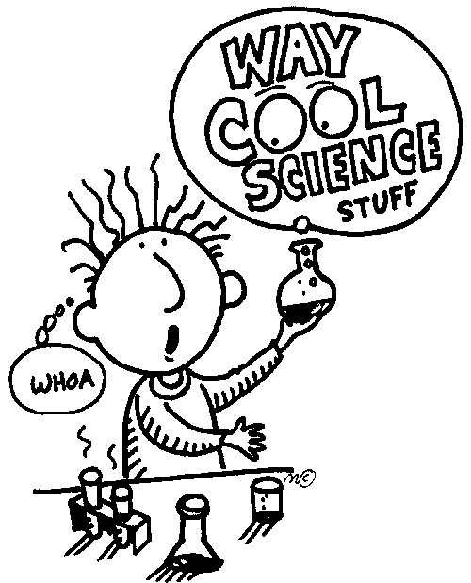
Young Scientist Convention
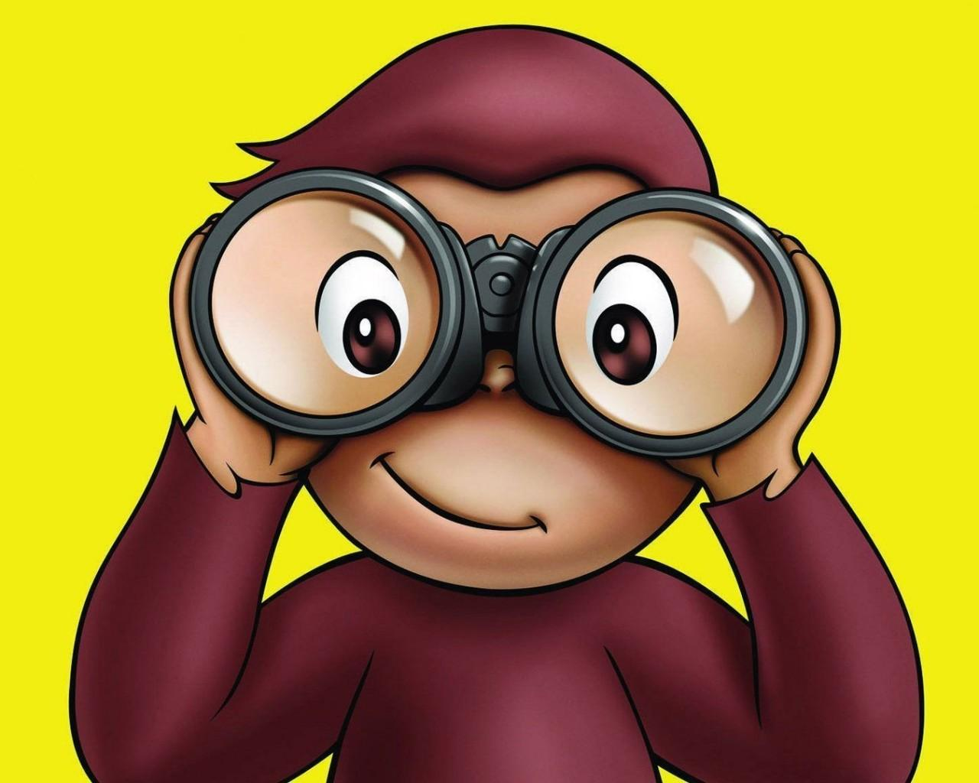

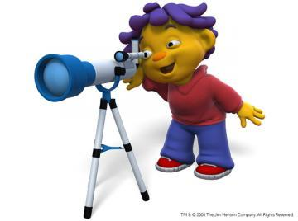

Grades K-2
Tuesday, February 13, 2018
6:00 – 6:45 pm

Introductory Letter to Parents
Dear Parents,
Community School is very excited to announce The Sixth Annual Young Scientist Convention! This project is optional and will be completed entirely at home.
We are confident the following benefits will result from your child’s participation in the Scientist Convention:
- Reinforcing grade level science, literacy, and math skills
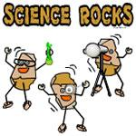
- Fostering curiosity, awareness, and creativity
- Increasing scientific knowledge
- Using and applying the scientific method
- Growing in the ability to work independently or
with a partner
- Having fun with science!
We hope that, with your enthusiastic encouragement, your child will participate in this enriching scientific experience! Don’t worry if you haven’t created a project before – anyone can do it!
First, become familiar with the guidelines and timeline presented in this booklet. Next, allow plenty of time to do the project, at least 4 weeks. This will give your child enough time to explore, come up with a question that interests him/her, do the experiment, and make the presentation. Try to make each work session brief, about 20 minutes, to accommodate short attention spans!
Try not to get possessive about the project! Let it end up looking like exactly what it is – the work of a young scientist! You will all feel considerable satisfaction when the project is complete. The project does not have to look perfect, or get perfect results to be a successful project. In fact, we encourage the exact opposite! Science can be messy, unpredictable, and have lots of mistakes – that is when the best learning occurs! Focus on the PROCESS not the PRODUCT!
We hope this information will assist you in the role of the parent guide. Have fun!
“Science is not merely a collection of facts printed in an encyclopedia.
It is a living adventure of the human spirit.” (Source unknown)
The Scientific Method
We are all scientists when we wonder, predict, try new things, and ask questions! Science is simply “a system of acquiring knowledge.” The Scientific Method looks like this:
- Observe and Explore
*Use senses to explore materials and the environment.
*Find out what interests you.
- Focus Question
*Ask questions through active exploration.
- Research the Question
*Seek answers through active exploration.
*Read books, ask grown-ups, watch videos, and look on the computer.
- Make a Hypothesis (a fancy science word for “prediction”)
*What do you think might happen based on what you know?
- Materials
*What materials did I use for the experiment?
- Conduct the Experiment
*What is my plan?
*What things will I keep the same? What things will I change?
- Record Data and Results
*Take pictures of the experiment.
*Create a chart, table, graph, thinking map, or diagram to show what happened.
- Form a Conclusion
*Answer your focus question. Does it match your hypothesis? Why or why not?
- Reflect
*What things went wrong in your experiment? What things were unexpected?
*Did you change what you were doing at first? Why?
*What did you learn? Maybe ask a new question based on your ideas and conclusions.
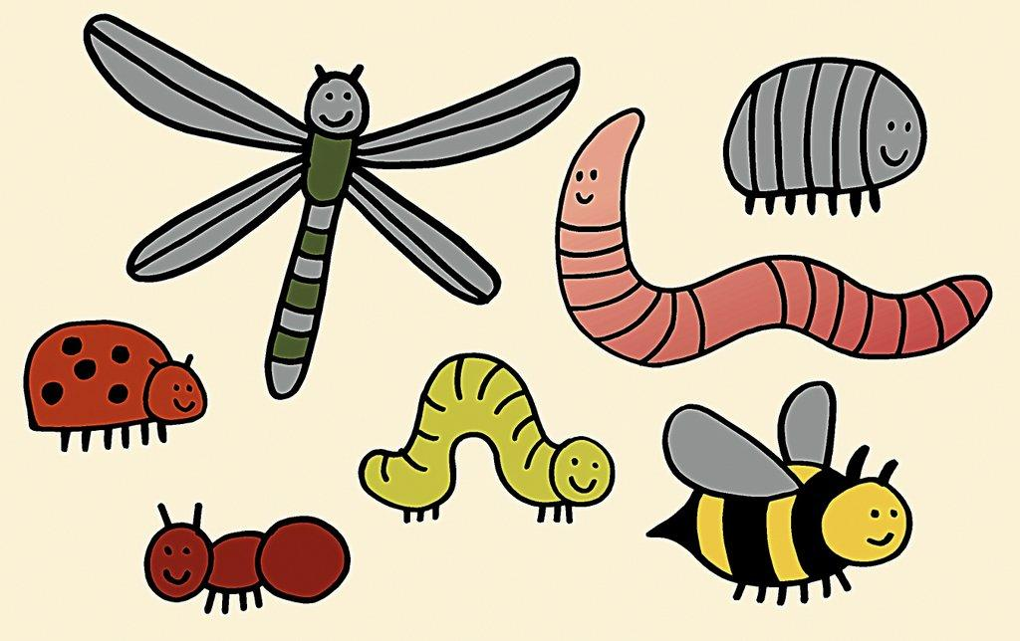
Observe and Explore Form
This is one of the most exciting parts! You get to choose what you are going to explore! First, you should know that there are three different categories of science that you can choose from!
- Life Science
*Studying living things
*Topics include: animals, plants, human body, behavior
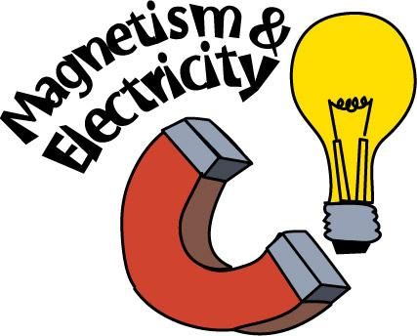
- Physical Science
*Trying to figure out how things work
*Topics include: matter, electricity, magnetism, sound, light
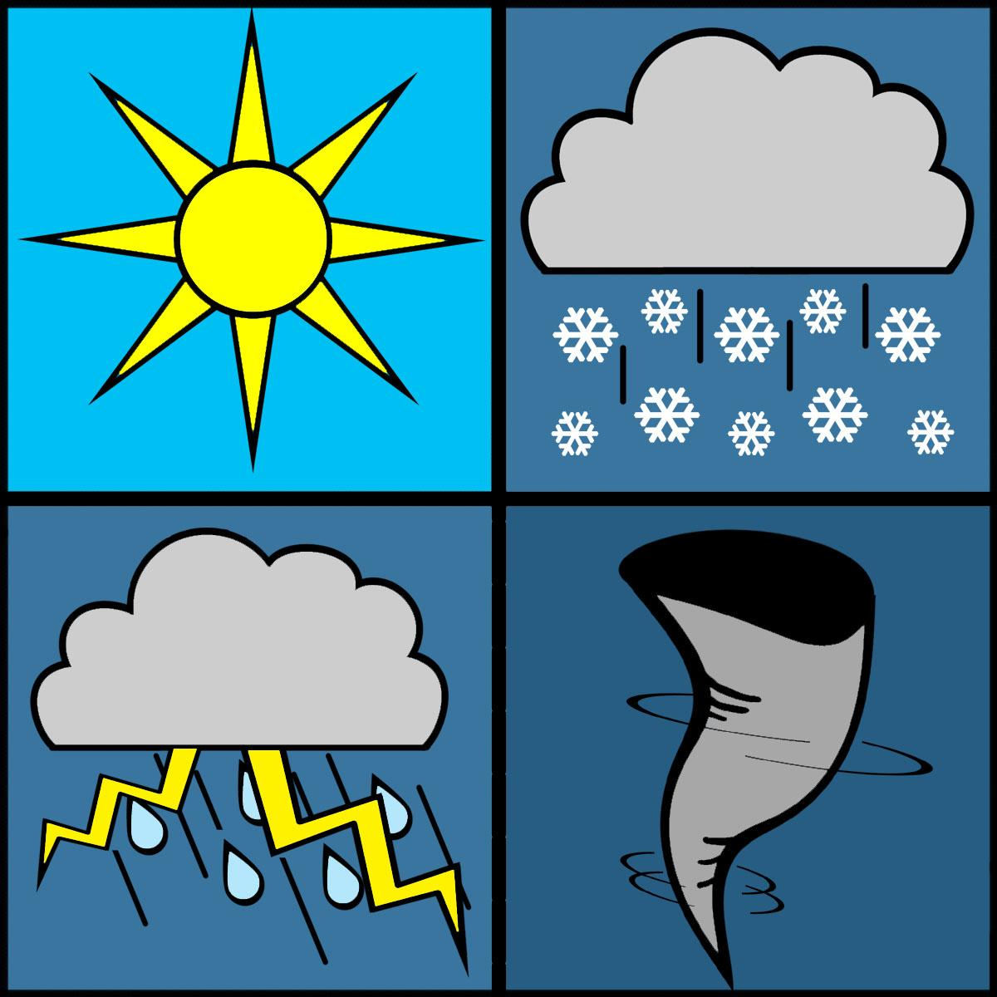
- Earth and Space Science
*Earth or objects in space
*Topics include: rocks, fossils, weather, space
Next, browse through these sample questions to help you come up with your own idea! Be creative and have fun!
Why is salt put on icy sidewalks? | Can plants grow without soil?
Does a baseball go farther if hit by a wood or metal bat? | Does holding a mirror in front of a fish change what a fish does?
In my class, who has the smallest hands, boys or girls? | Which cheese (or bread) grows mold the fastest?
Will water with salt evaporate faster than water without salt? | Which brand of paper towel is the strongest (or the most absorbent)?
Do suction cups stick equally well to different surfaces? | Does a bath take less water than a shower?
Which brand of popcorn pops the most kernels? | Will more air in a basketball make it bounce higher?
Does sugar prolong the life of cute flowers? | How does a pulley help you do work?
Does the shape of a kite affect its flight? | Can things be identified just by their smell?
How far can a snail travel in one minute? | In which soil do plants grow best?
Do roots of a plant always grow downward? | Does an ice cube melt faster in air or water?
Does the color of water affect evaporation? | Do wheels reduce friction?
How does omitting an ingredient affect the taste of a cookie? | Which student in my class (or person in my family) has the greatest lung capacity?
Does warm water freeze faster than cold? | Can you tell time without a watch or clock?
On which type of battery do toys run the longest? | Can the design of a paper airplane make it fly farther?
What magnet is strongest? | Do coins corrode faster in fresh or salt water?
Does a ball roll farther on grass or dirt? | Do ants like cheese or sugar better?
What kind of juice cleans pennies best? | What kinds of things do magnets attract?
Coming Up with a Good Focus Question
Once you have a topic that you like and you are interested in, it’s time to write a question or identify a problem within that topic. There are different types of focus questions:

The Effect Question:
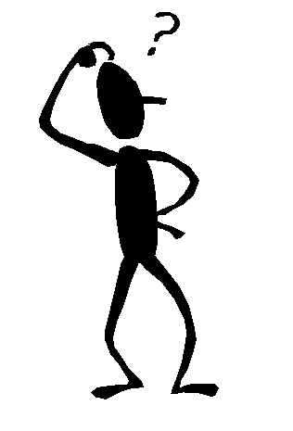
What is the effect of _______________________ on________________________?
brands of soda a piece of meat
temperature the size of a balloon
The How Does Affect Question:
How does the _______________________ affect________________________?
temperature the growth of plants
the color of water evaporation
The Which/What and Verb Question:
Which/What _______________________ (verb)________________________?
paper towel is most absorbent
bread molds most quickly

***If you need additional help coming up with a focus question or idea, check out:
www.sciencebuddies.org
“The award-winning, non-profit Science Buddies empowers K-12 students, parents, and teachers to quickly and easily find free project ideas and help in all areas of science from physics to food science and music to microbiology.”
You can browse ideas from real scientists, ask science experts for advice, and use the science fair guide to help plan your project!

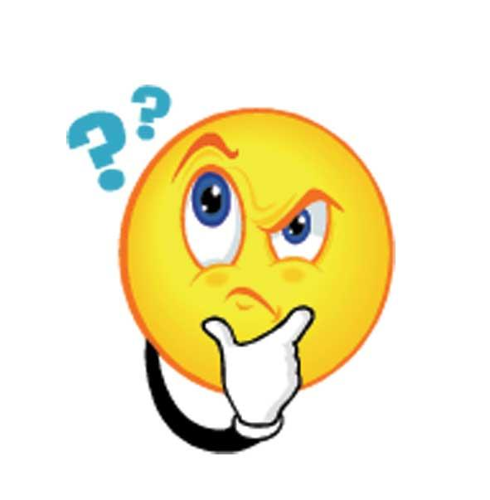
Focus Question Form
Return this form to your teacher by Friday, January 12.
Young Scientist Name(s):_______________________________________________
Grade:__________ Teacher(s):__________________________________________
*Parent/Guardian Signature(s):_________________________________________
___________________________________________________________________
Now it’s your turn! After you observe and explore, it’s time to create a focus question and create a plan to start your project! Your teacher will read your question and plan. Then she will let you know if you are ready to start your experiment.
Write your Focus Question here:
__________________________________________________________
__________________________________________________________
__________________________________________________________
Here is my basic Plan/Procedure for the project:
__________________________________________________________
__________________________________________________________
__________________________________________________________
__________________________________________________________
__________________________________________________________
__________________________________________________________
Teacher Comments: _____________________________________________________________
______________________________________________________________________________
- Your project is ready to go!
- You need to revise your project!
Research
Focus Question:________________________________________________________________
_____________________________________________________________________________
______________________________________________________________________________
Research: My focus question is about this topic:______________________________________
(Sample topics are magnetism, electricity, absorbency, taste, plant growth, simple machines. Ask your teacher or grown up to help you find the topic of your project)
Books I/we found in the library on the topic are:
Title: Author:
______________________________________________________________________________
______________________________________________________________________________
Internet sites that I/we found on the topic are:
______________________________________________________________________________
______________________________________________________________________________
People I/we talked to about the topic are:
______________________________________________________________________________
______________________________________________________________________________
Some important points that I/we learned about the topic are:
______________________________________________________________________________
______________________________________________________________________________
______________________________________________________________________________
______________________________________________________________________________
______________________________________________________________________________
______________________________________________________________________________
______________________________________________________________________________
______________________________________________________________________________
Hypothesis, Materials, Plan
A hypothesis is a guess about how or why something happens. You should form a hypothesis about your question before you begin your experiment. It’s OK if your hypothesis is not right!
Hypothesis: I/We think that_______________________________________________________
______________________________________________________________________________
______________________________________________________________________________
because my/our research shows____________________________________________________
______________________________________________________________________________
______________________________________________________________________________
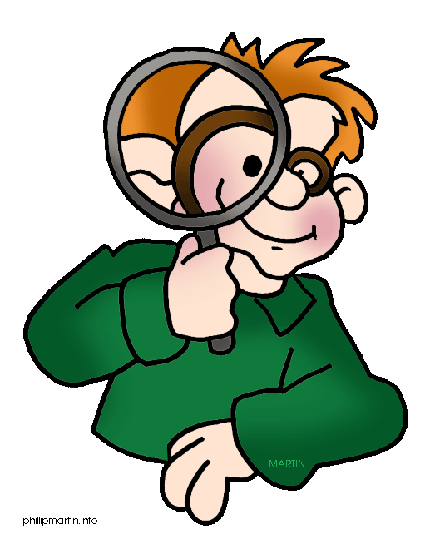
______________________________________________________________________________

List the Materials that you will need for your science experiment here.
Don’t forget to take pictures!
1.__________________________________ 6. __________________________________
2. __________________________________ 7. __________________________________
3. __________________________________ 8. __________________________________
4. __________________________________ 9. __________________________________
5. __________________________________ 10. _________________________________

List the Procedure (the steps!) you have to do in order to do the experiment here.
Don’t forget to take pictures!
1. First, _______________________________________________________________________
2. Second, _____________________________________________________________________
3. Third, _______________________________________________________________________
4. Fourth, _____________________________________________________________________
5. ____________________________________________________________________________
6. ____________________________________________________________________________
Data/Results
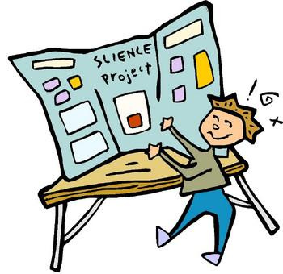
Data: Design a thinking map, table, graph, diagram, etc. to collect your information. Don’t forget to have someone take pictures of you doing the experiment!
(Feel free to use the computer or your own paper to present your data!)

Conclusion and Reflection
Conclusion: Now tell us the answer to your focus question! Was your hypothesis correct? Why or why not? Did it work? Why did it work or why did it not work? What do the results tell you? What did you prove?
______________________________________________________________________________
______________________________________________________________________________
______________________________________________________________________________
______________________________________________________________________________
______________________________________________________________________________
______________________________________________________________________________
______________________________________________________________________________
______________________________________________________________________________
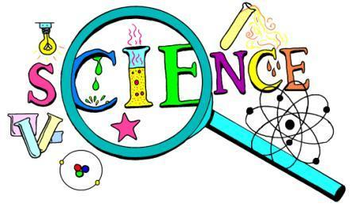

Reflection: This is your chance to tell us why your experiment is important in real life! What does it teach other people? What kinds of things would you like to experiment with next after doing this project? Why is this experiment important?
______________________________________________________________________________
______________________________________________________________________________
______________________________________________________________________________
______________________________________________________________________________
______________________________________________________________________________
______________________________________________________________________________
______________________________________________________________________________
______________________________________________________________________________
Presentation
For the Presentation, your child will need a “Tri-fold Display Board.” These are sold at office supply stores, Walmart, Target, etc. This is an example of how to set up a display board. However, let your child be the guide for this part! We do want the display neat, but we want it to look like student work! Use all those pictures you took, and use thinking maps, drawings, diagrams, charts, tables, and models. You can use the worksheets provided in this packet or create your own. The night of the convention, bring your “Tri-fold Display Board,” and you may also bring notebooks, a model, or materials from your project you would like to display.
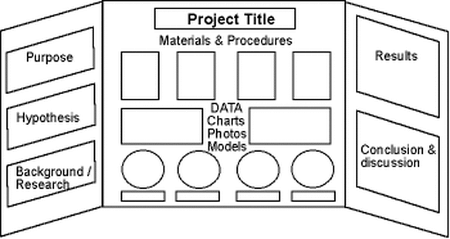

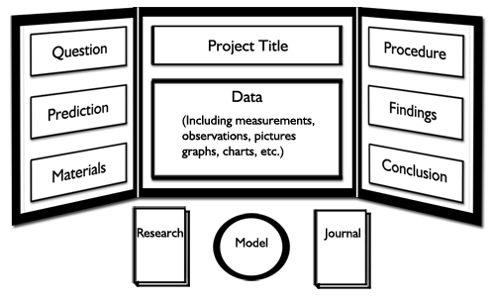

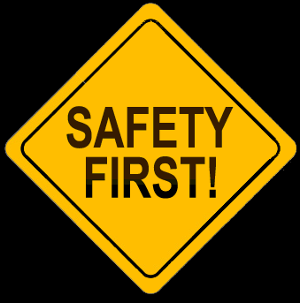
Young Scientist Convention Safety Rules
- No open flames are permitted
- No dangerous or combustible chemicals are permitted.
- All electrical safety rules should be obeyed.
- Expensive or highly fragile items should not be displayed. If these types of items are essential to the project, use photos or simulations.
- No active chemical reactions may be performed in the exhibit area (For example, the vinegar/baking soda volcanoes). These types of projects should be done at home and displayed using photos.
- Avoid bringing open containers of liquid that can easily spill.
- To help avoid the potential for allergic reactions, please do not use products that contain nuts or bring in live animals with hair.
Helpful Websites
Science Buddies:
www.sciencebuddies.org
Internet Public Library Science Fair Guide:
http://www.ipl.org/div/projectguide/
Science Fair Project Ideas
http://www.education.com/science-fair/
Try Science:
http://tryscience.com
Discovery Education Science Fair Central:
http://school.discoveryeducation.com/sciencefaircentral/
Good Luck with your project! See you at the Young Scientist Convention on February 13!
Science Project Suggested Timeline
TASK | GUIDELINE | FINISHED
- Return your Focus Question Form to your teacher. | DUE Fri., January 12
- Purchase or make a display board from an office supply or craft store (Michael’s, Staples, Walmart)
- Research – begin to collect/read books on your topic. | By Fri., January 12
- Develop a hypothesis based on your research. | By Fri., January 19
- Decide on a procedure that you will use to test your hypothesis. | By Fri., January 19
- Make a list of your materials. Gather your materials. | By Fri., January 19
- Conduct your experiment. Record data. Take pictures! | By Fri., January 26
- Organize your data and results. | By Fri., February 2
- Write your conclusion based on your results. Write a reflection on how your project connects to the “real world!” | By Fri., February 2
- Proofread all written responses or have someone else proofread them. | By Fri., February 9
- Assemble your science fair display board. | DUE Tues., February 13
- Bring your project and display board to Community School at 5:45 pm to pick up your name card, find your project location, and set up your display board and materials. After the Convention, leave your project at school until the following day! | Tues., February 13  6:00 – 6;45 pm  Arrive for setup at Community School at 5:45 pm
- Arrange for your project to be picked up and taken home. | By Fri., February 16
