Community School Proudly Presents…

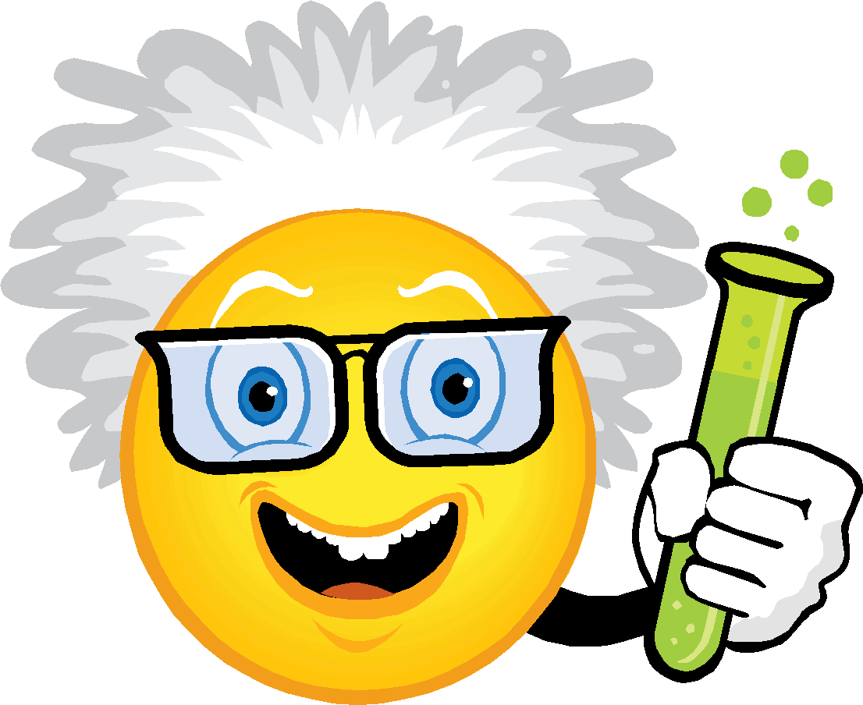
The Sixth Annual
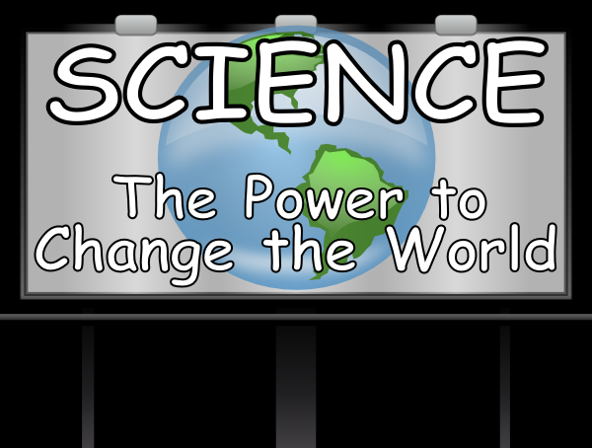
Junior Scientist
Convention

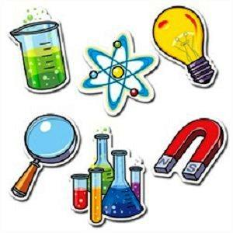

Grades 3-5
Tuesday, February 27, 2018
6:00 – 7:00 pm
Introductory Letter to Parents
Dear Parents,
Community School is very excited to announce The Sixth Annual Junior Scientist Convention! This project is optional and will be completed entirely at home.
Attached, you will find the guide to creating a fantastic project. Although parental support and assistance are essential to your child’s success, a general rule of thumb to go by is:
- 4th and 5th graders should be doing almost the entire project by themselves.
- 3rd graders should be able to do many parts by themselves.
We are confident the following benefits will result from your child’s participation in the Scientist Convention:
- Reinforcing grade level science, literacy, and math skills
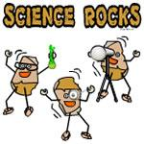
- Fostering curiosity, awareness, and creativity
- Increasing scientific knowledge
- Using and applying the scientific method
- Growing in the ability to work independently, or
with a partner
- Having fun with science!
We hope that, with your enthusiastic encouragement, your child will participate in this enriching scientific experience! Don’t worry if you haven’t created a project before – anyone can do it! You can also talk to someone who did the project last year for tips and advice!
First, become familiar with the guidelines and timeline presented in this booklet. Next, allow plenty of time to do the project, at least 4 weeks. This will give your child enough time to explore, come up with a question that interests him/her, do the experiment, and make the display board.
If you need extra copies of the Science Convention guidelines, they are available on the school website: http://communityschoolri.com/
“Science is not merely a collection of facts printed in an encyclopedia.
It is a living adventure of the human spirit.” (Source unknown).
Helpful Hints for Parents
We want this to be a fun project for you and your child.
Success is when your child can answer their investigation question,
is having fun, and knows more than when they started.
Here are some tips for enjoying the experience:

- The goal is that your child learns the “scientific method” through direct experience.
- For their daily reading, try choosing a science book/article that can be part of the research for their project.
- Try to answer questions with questions. Even if you know the answer, guide your child to discover it for him or herself.
- If you allow your child to use the Internet for research, verify that the site is reliable. Remember that anyone can create a website, but that does not mean the information is correct. DOT “org,” “gov,” or “edu” are generally trustworthy, as are large, recognized groups (i.e. Discovery Education, Museum of Science, or University of RI).
- Try not to get possessive about the project! Let it end up looking like exactly what it is – the work of a junior scientist! You will all feel considerable satisfaction when the project is complete. The project does not have to look perfect, or get perfect results to be a successful project. In fact, we encourage the exact opposite! Science can be messy, unpredictable, and have lots of mistakes – that is when the best learning occurs! Focus on the PROCESS not the PRODUCT!

We hope this information will assist you in the role of the parent guide. If you have further questions or concerns, contact your child’s teacher.
What Type of Project Should You Do?
We would like you to do an EXPERIMENT! Why? They are fun, interesting, and most importantly, they take you through the Scientific Method. This is the way scientists investigate in real science labs.
The Scientific Method
- Observe and Explore
*Use senses to explore materials and the environment.
*Find out what interests you.
- Focus Question
*Ask questions through active exploration.
- Research the Question
*Seek answers through active exploration.
*Read books, ask grown-ups, watch videos, and look on the computer.
- Make a Hypothesis (a fancy science word for “prediction”)
*What do you think might happen based on what you know?
- Materials
*What materials did I use for the experiment?
- Conduct the Experiment
*What is my plan?
*What things will I keep the same? What things will I change? (Control, Variables)
- Record Data and Results
*Take pictures of the experiment.
*Create a chart, table, graph, thinking map, or diagram to show what happened.
- Form a Conclusion
*Answer your focus question. Does it match your hypothesis? Why or why not?
- Reflect
*What things went wrong in your experiment? What things were unexpected?
*Did you change what you were doing at first? Why?
*What did you learn? Maybe ask a new question based on your ideas and conclusions.
Choosing a Topic to Investigate
This is one of the most exciting parts! You get to choose what you are going to explore! First, you should know that there are three different categories of science that you can choose from!
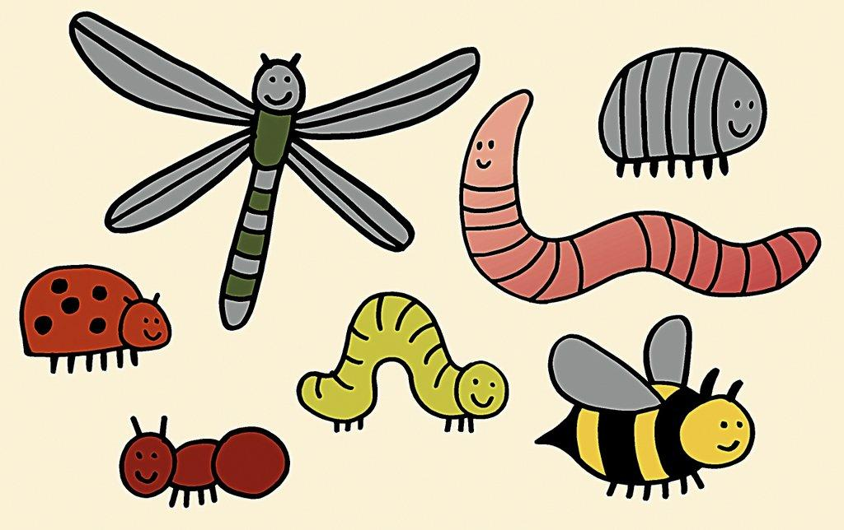

- Life Science
*Studying living things
*Topics include: animals, plants, human body, behavior
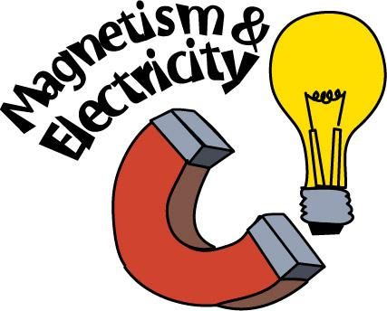
*Please respect all life forms. Do not perform an experiment that will harm an animal.

- Physical Science
*Trying to figure out how things work
*Topics include: matter, electricity, magnetism, sound, light
*This is the category where you can try mixing things together to see what will happen (with parent permission and specific research, of course!)
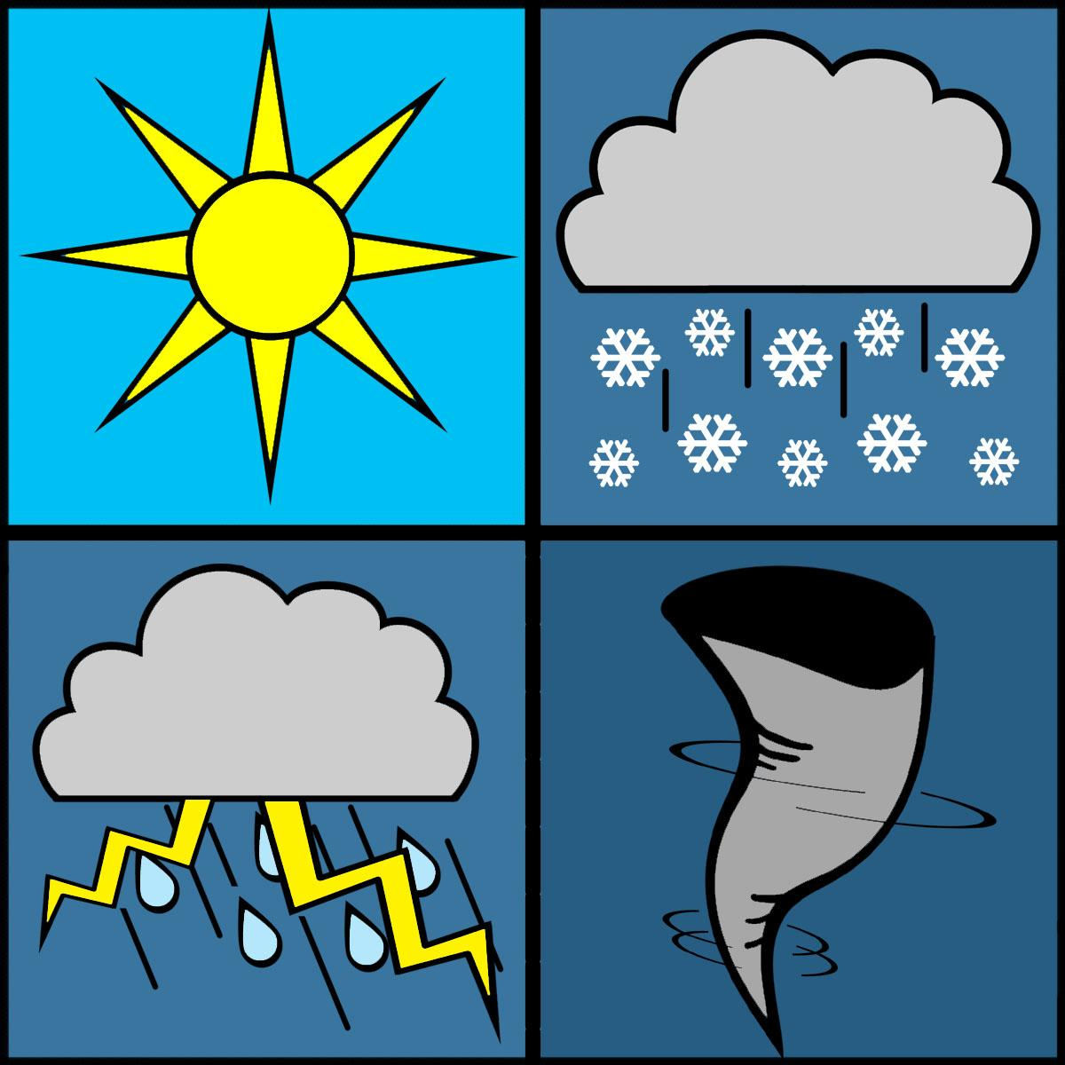

- Earth and Space Science
*Earth or objects in space
*Topics include: rocks, fossils, weather, space
*Be careful with this category! Make sure you’re doing an experiment and not just
showing off your rock collection or making a model of the solar system.

If you need help coming up with an idea, check out:
www.sciencebuddies.org
“The award-winning, non-profit Science Buddies empowers K-12 students, parents, and teachers to quickly and easily find free project ideas and help in all areas of science from physics to food science and music to microbiology.”
You can browse ideas from real scientists, ask science experts for advice, and use the science fair guide to help plan your project!

Coming Up with a Good Focus Question
Once you have a topic that you like and you are interested in, it’s time to write a question or identify a problem within that topic. There are different types of focus questions:

The Effect Question:
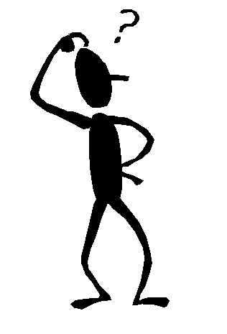
What is the effect of _______________________ on________________________?
vinegar (acid) different minerals and rocks
temperature the size of a balloon
oil a ramp
eye color pupil dilation
The How Does Affect Question:
How does the _______________________ affect________________________?
the color of a material its absorption of heat
number of magnets the strength of magnetism
humidity the growth of fungi
The Which/What and Verb Question:
Which/What _______________________ (verb)________________________?
paper towel is most absorbent
bread molds most quickly
detergent makes the most bubbles
foods do mealworms prefer
battery lasts the longest
Give it a try:
Create your own focus question using one of the models listed on this page! When you are confident about your question, fill out the “Focus Question Form” and return it to your teacher for approval!
__________________________________________________________________________________________________________________________________________________________________________________________________________________________________________
______________________________________________________________________________
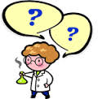
Focus Question Form
Return this form to your teacher by Friday, January 12.
Junior Scientist Name(s):_____________________________________________
Grade:__________ Teacher(s):_______________________________________
*Parent/Guardian Signature(s):_________________________________________
__________________________________________________________________
Write your Focus Question here (this is the question you will test for your project):
__________________________________________________________
__________________________________________________________
__________________________________________________________
__________________________________________________________
Here is my basic Plan/Procedure for the project:
__________________________________________________________
__________________________________________________________
__________________________________________________________
__________________________________________________________
__________________________________________________________
__________________________________________________________
Teacher Comments: _____________________________________________________________
______________________________________________________________________________
- Your project is ready to go!
- You need to revise your project!
Research
Focus Question:________________________________________________________________
_____________________________________________________________________________
______________________________________________________________________________
Research: My/our focus question is about this topic:___________________________________
(Sample topics are magnetism, electricity, absorbency, taste, plant growth, simple machines. Ask your teacher or grown up to help you find the topic of your project)
Books I found in the library on my/our topic are:
Title: Author:
______________________________________________________________________________
______________________________________________________________________________
Internet sites that I found on my/our topic are:
______________________________________________________________________________
______________________________________________________________________________
People I talked to about my/our topic are:
______________________________________________________________________________
______________________________________________________________________________
Some important points that I learned about my/our topic are:
______________________________________________________________________________
______________________________________________________________________________
______________________________________________________________________________
______________________________________________________________________________
______________________________________________________________________________
______________________________________________________________________________
______________________________________________________________________________
______________________________________________________________________________
Hypothesis and Materials
A hypothesis is a guess about how or why something happens. You should form a hypothesis about your question before you begin your experiment. Use your research to help you form your hypothesis. It’s OK if your hypothesis is not right!
Hypothesis: I think that__________________________________________________________
______________________________________________________________________________
______________________________________________________________________________
because my/our research shows____________________________________________________
______________________________________________________________________________
______________________________________________________________________________
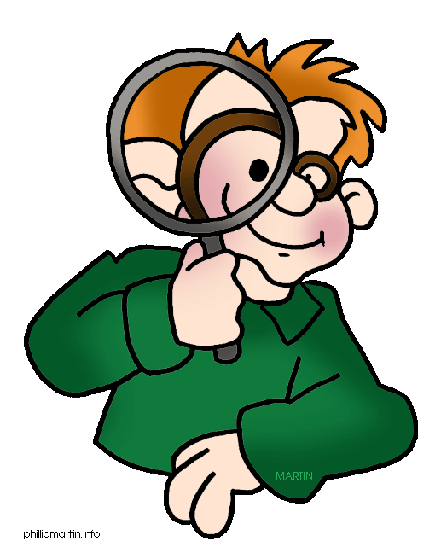
_____________________________________________________________________________

Now you get to design your experiment! List the Materials that you will need for your science experiment here. Don’t forget to take pictures for your display board!
1.__________________________________ 6. __________________________________
2. __________________________________ 7. __________________________________
3. __________________________________ 8. __________________________________
4. __________________________________ 9. __________________________________
5. __________________________________ 10. _________________________________

Procedure
List the Procedure (the steps!) you have to do in order to do the experiment here.
Don’t forget to take pictures as you do the experiment! You can add these photos to your display board.
1. First, _______________________________________________________________________
2. Second, _____________________________________________________________________
3. Third, _______________________________________________________________________
4. Fourth, _____________________________________________________________________
5. ____________________________________________________________________________
6. ____________________________________________________________________________
7. ____________________________________________________________________________
8. ____________________________________________________________________________

Variables: The variables are any factors that can change in an experiment. When you are doing your experiment, you should only change one variable at a time in order to get accurate results. For example, if you were testing which paper towel is most absorbent, each type of paper towel should soak up the same liquid on the same surface, same location, same amount, and be the same size (these are the controlled variables). The only variable you would change during the experiment would be the type of paper towel (this is called the independent variable). The independent variable is the factor you are testing. The results of the test are called the dependent or responding variables. The responding variable is what happens as a result of your test. If you know what your variables are, you can easily collect data.

Test, Test, Test: In order to have a good experiment, the results should be consistent. You need to make sure your procedure works every time! You should repeat your procedure 3 or more times. The more you do it, the more accurate your results will be.

Collect your Data: Every time you do your experiment, record the results. Organize the results so they are easy to read and understand. Use your science notebook from class for ideas on how to organize your data. You can use thinking maps, tables, graphs, charts, lists, etc.

Data
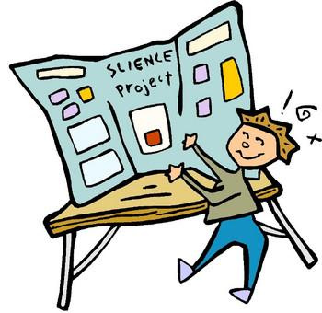
Data: Design a thinking map, table, chart, graph, diagram, etc. to collect your information here. Don’t forget to have someone take pictures of you doing the experiment!
(Feel free to use the computer or your own paper to present your data!)

Conclusion and Reflection
Conclusion: Now tell us the answer to your focus question! Was your hypothesis correct? Why or why not? Did it work? Why did it work or why did it not work? What do the results tell you? What did you prove?
______________________________________________________________________________
______________________________________________________________________________
______________________________________________________________________________
______________________________________________________________________________
______________________________________________________________________________
______________________________________________________________________________
______________________________________________________________________________
______________________________________________________________________________
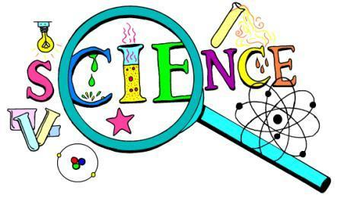

Reflection: This is your chance to tell us why your experiment is important in real life! What does it teach other people? What kinds of things would you like to experiment with next after doing this project?
______________________________________________________________________________
______________________________________________________________________________
______________________________________________________________________________
______________________________________________________________________________
______________________________________________________________________________
______________________________________________________________________________
______________________________________________________________________________
______________________________________________________________________________
Presentation
For the Presentation, your child will need a “Tri-fold Display Board.” These are sold at office supply stores, Walmart, Target, etc. This is an example of how to set up a display board. However, let your child be the guide for this part! We do want the display neat, but we want it to look like student work! Use all those pictures you took, and use drawings, diagrams, charts, tables, and models.
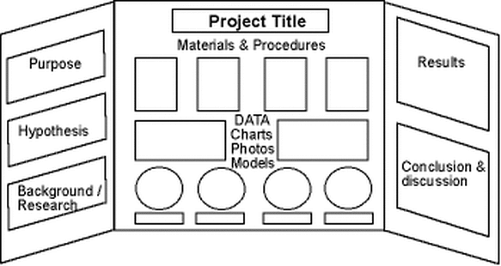

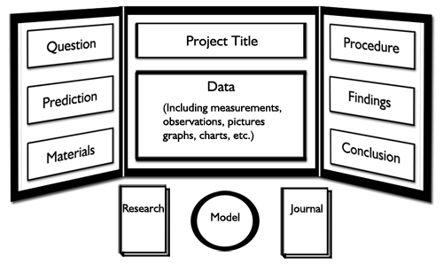

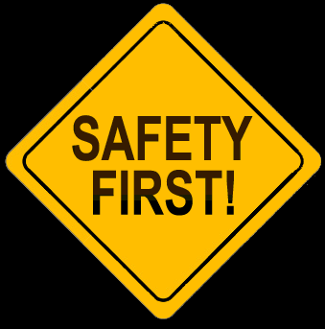
Junior Scientist Convention Safety Rules
- No open flames are permitted
- No dangerous or combustible chemicals are permitted.
- All electrical safety rules should be obeyed.
- Expensive or highly fragile items should not be displayed. If these types of items are essential to the project, use photos or simulations.
- No active chemical reactions may be performed in the exhibit area (For example, the vinegar/baking soda volcanoes). These types of projects should be done at home and displayed using photos.
- Avoid bringing open containers of liquid that can easily spill.
- To help avoid the potential for allergic reactions, please do not use products that contain nuts or bring in live animals with hair.
Helpful Websites
Science Buddies:
www.sciencebuddies.org
Internet Public Library Science Fair Guide:
http://www.ipl.org/div/projectguide/
Science Fair Project Ideas
http://www.education.com/science-fair/
Try Science:
http://tryscience.com
Discovery Education Science Fair Central:
http://school.discoveryeducation.com/sciencefaircentral/
Good Luck with your project! See you at the Junior Scientist Convention on February 27!
Science Project Suggested Timeline
TASK | GUIDELINE | FINISHED
- Return your Focus Question Form to your teacher. | DUE Fri., January 12
- Purchase or make a display board from an office supply or craft store (i.e. Michael’s, Staples, Walmart)
- Research – begin to collect/read books on your topic. | By Fri., January 12
- Develop a hypothesis based on your research. | By Fri., January 19
- Decide on a procedure that you will use to test your hypothesis. | By Fri., January 19
- Make a list of your materials. Gather your materials. | By Fri., January 19
- Conduct your experiment, record data, take pictures! | By Fri., February 2
- Organize your data and results. | By Fri., February 9
- Write your conclusion based on your results. Write a reflection on how your project connects to the “real world!” | By Fri., February 16
- Proofread all written responses or have someone else proofread them. | By Fri., February 23
- Assemble your science fair display board. | DUE Tues., February 27
- Bring your project and display board to Community School at 5:45 pm to pick up your name card, find your project location, and set up your display board and materials. After the Convention, leave your project at school until the following day! | Tues., February 27  6:00 – 7:00 pm  Arrive for Setup at Community School at 5:45 pm
- Arrange for the project to be picked up & taken home. | By Fri., March 2
*The Young Scientist Convention for grades K-2 will be held on Tuesday, February 13, from 6:00 – 6:45 pm. Feel free to come and get some ideas for your display board!
